Carole Gasaro

76832022

Webtech Final Project

**FRAMING TEMPLATE:**



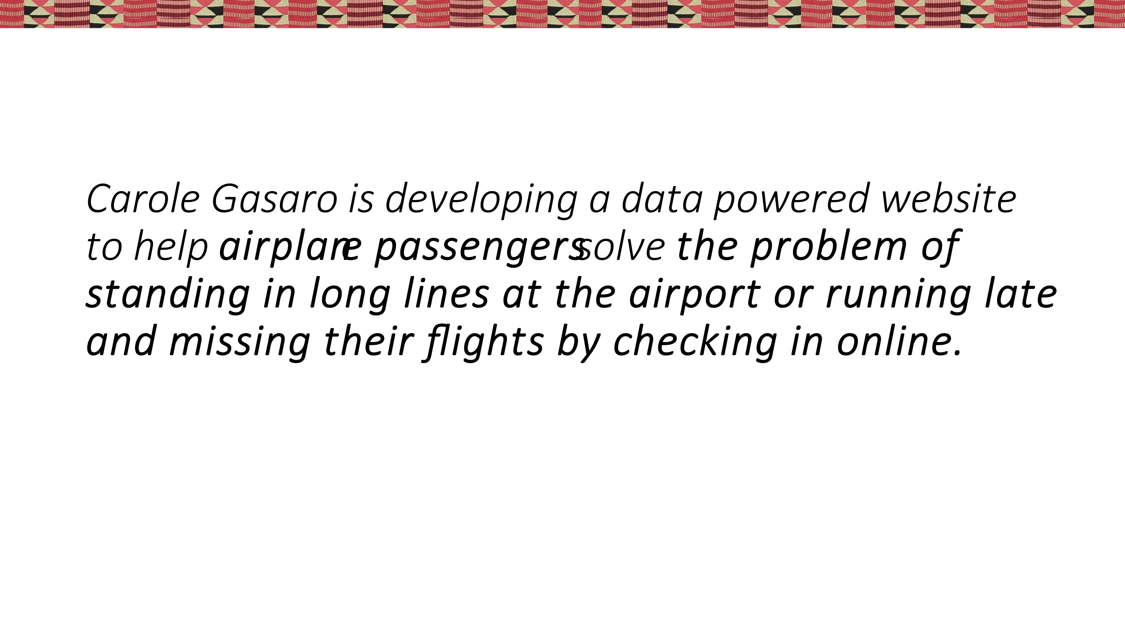

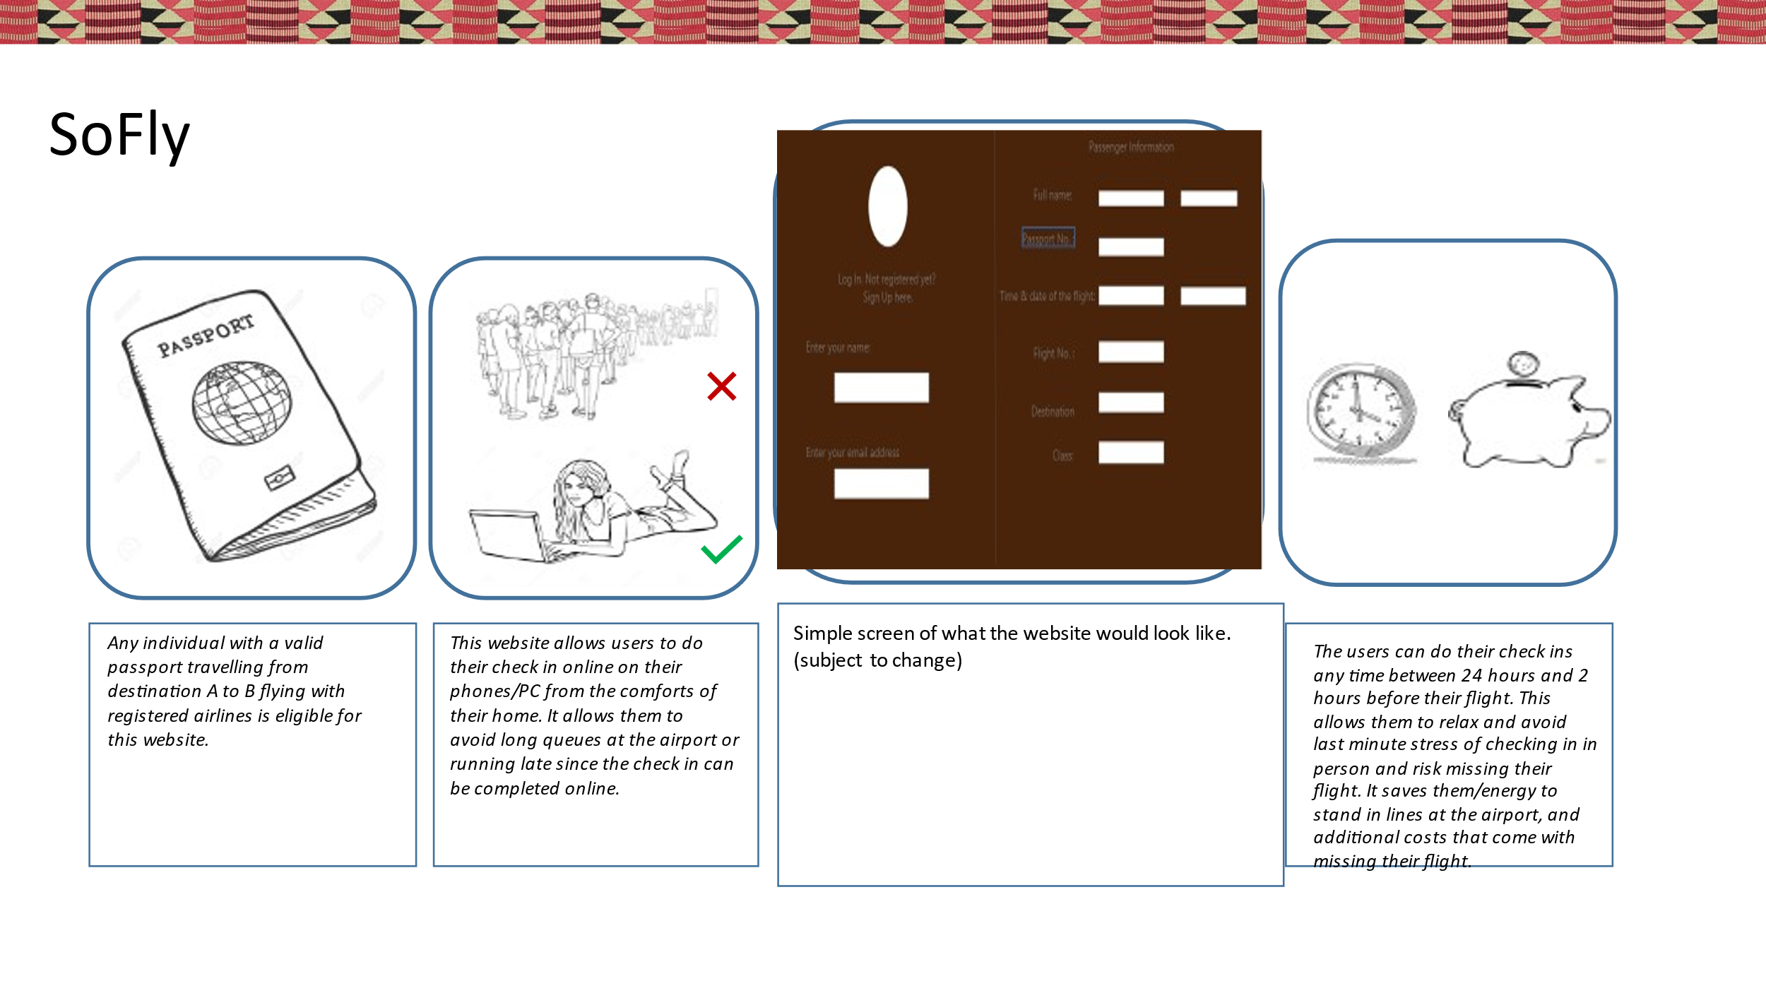

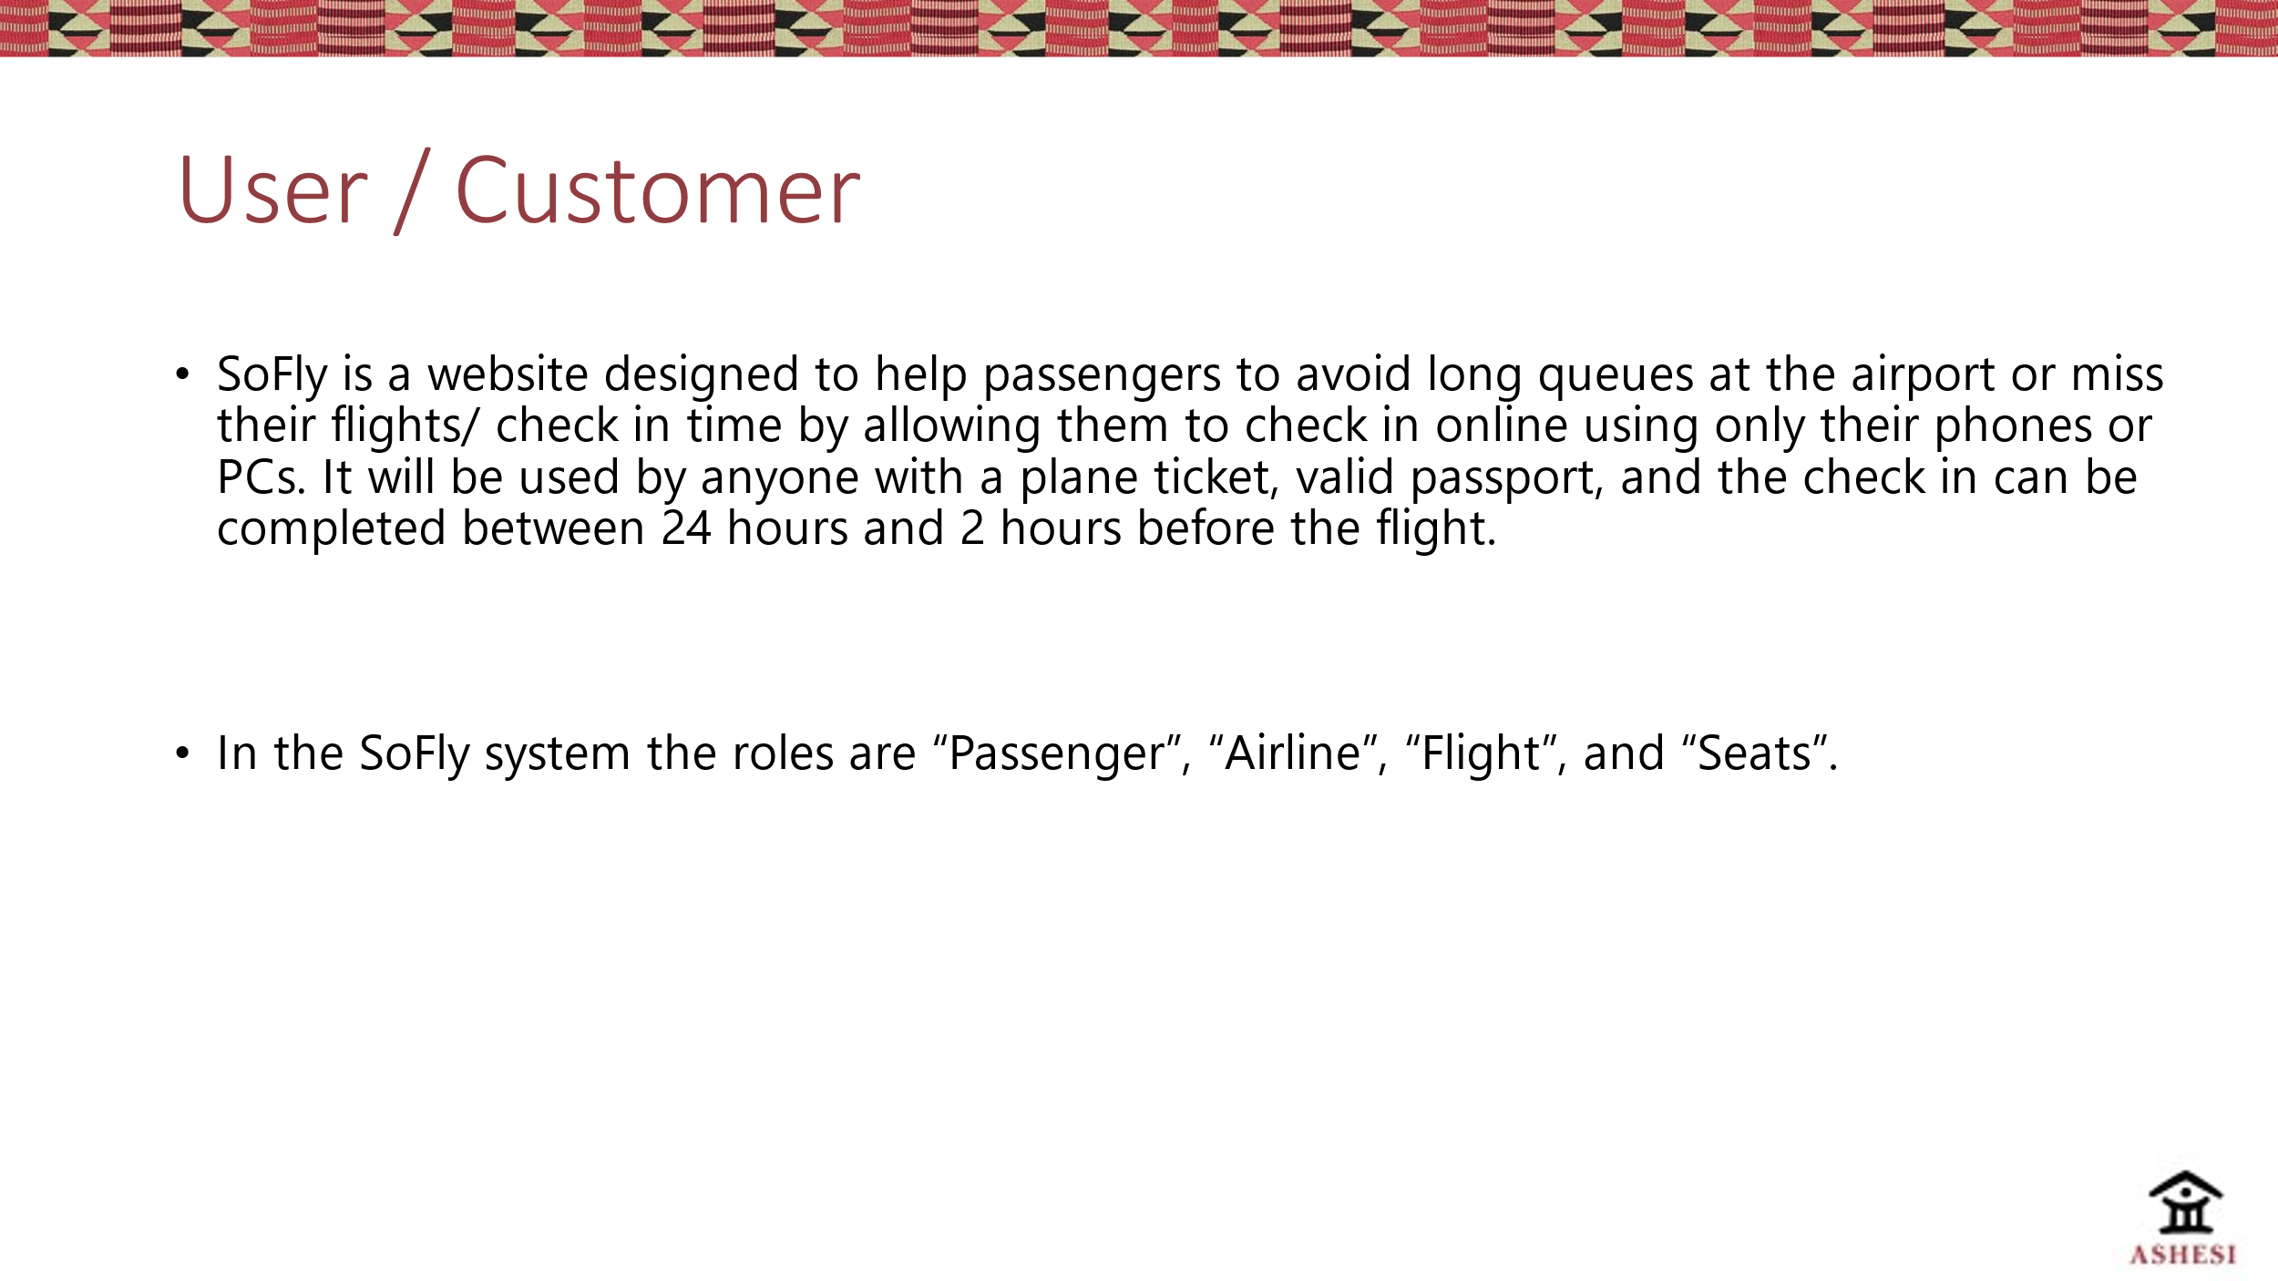

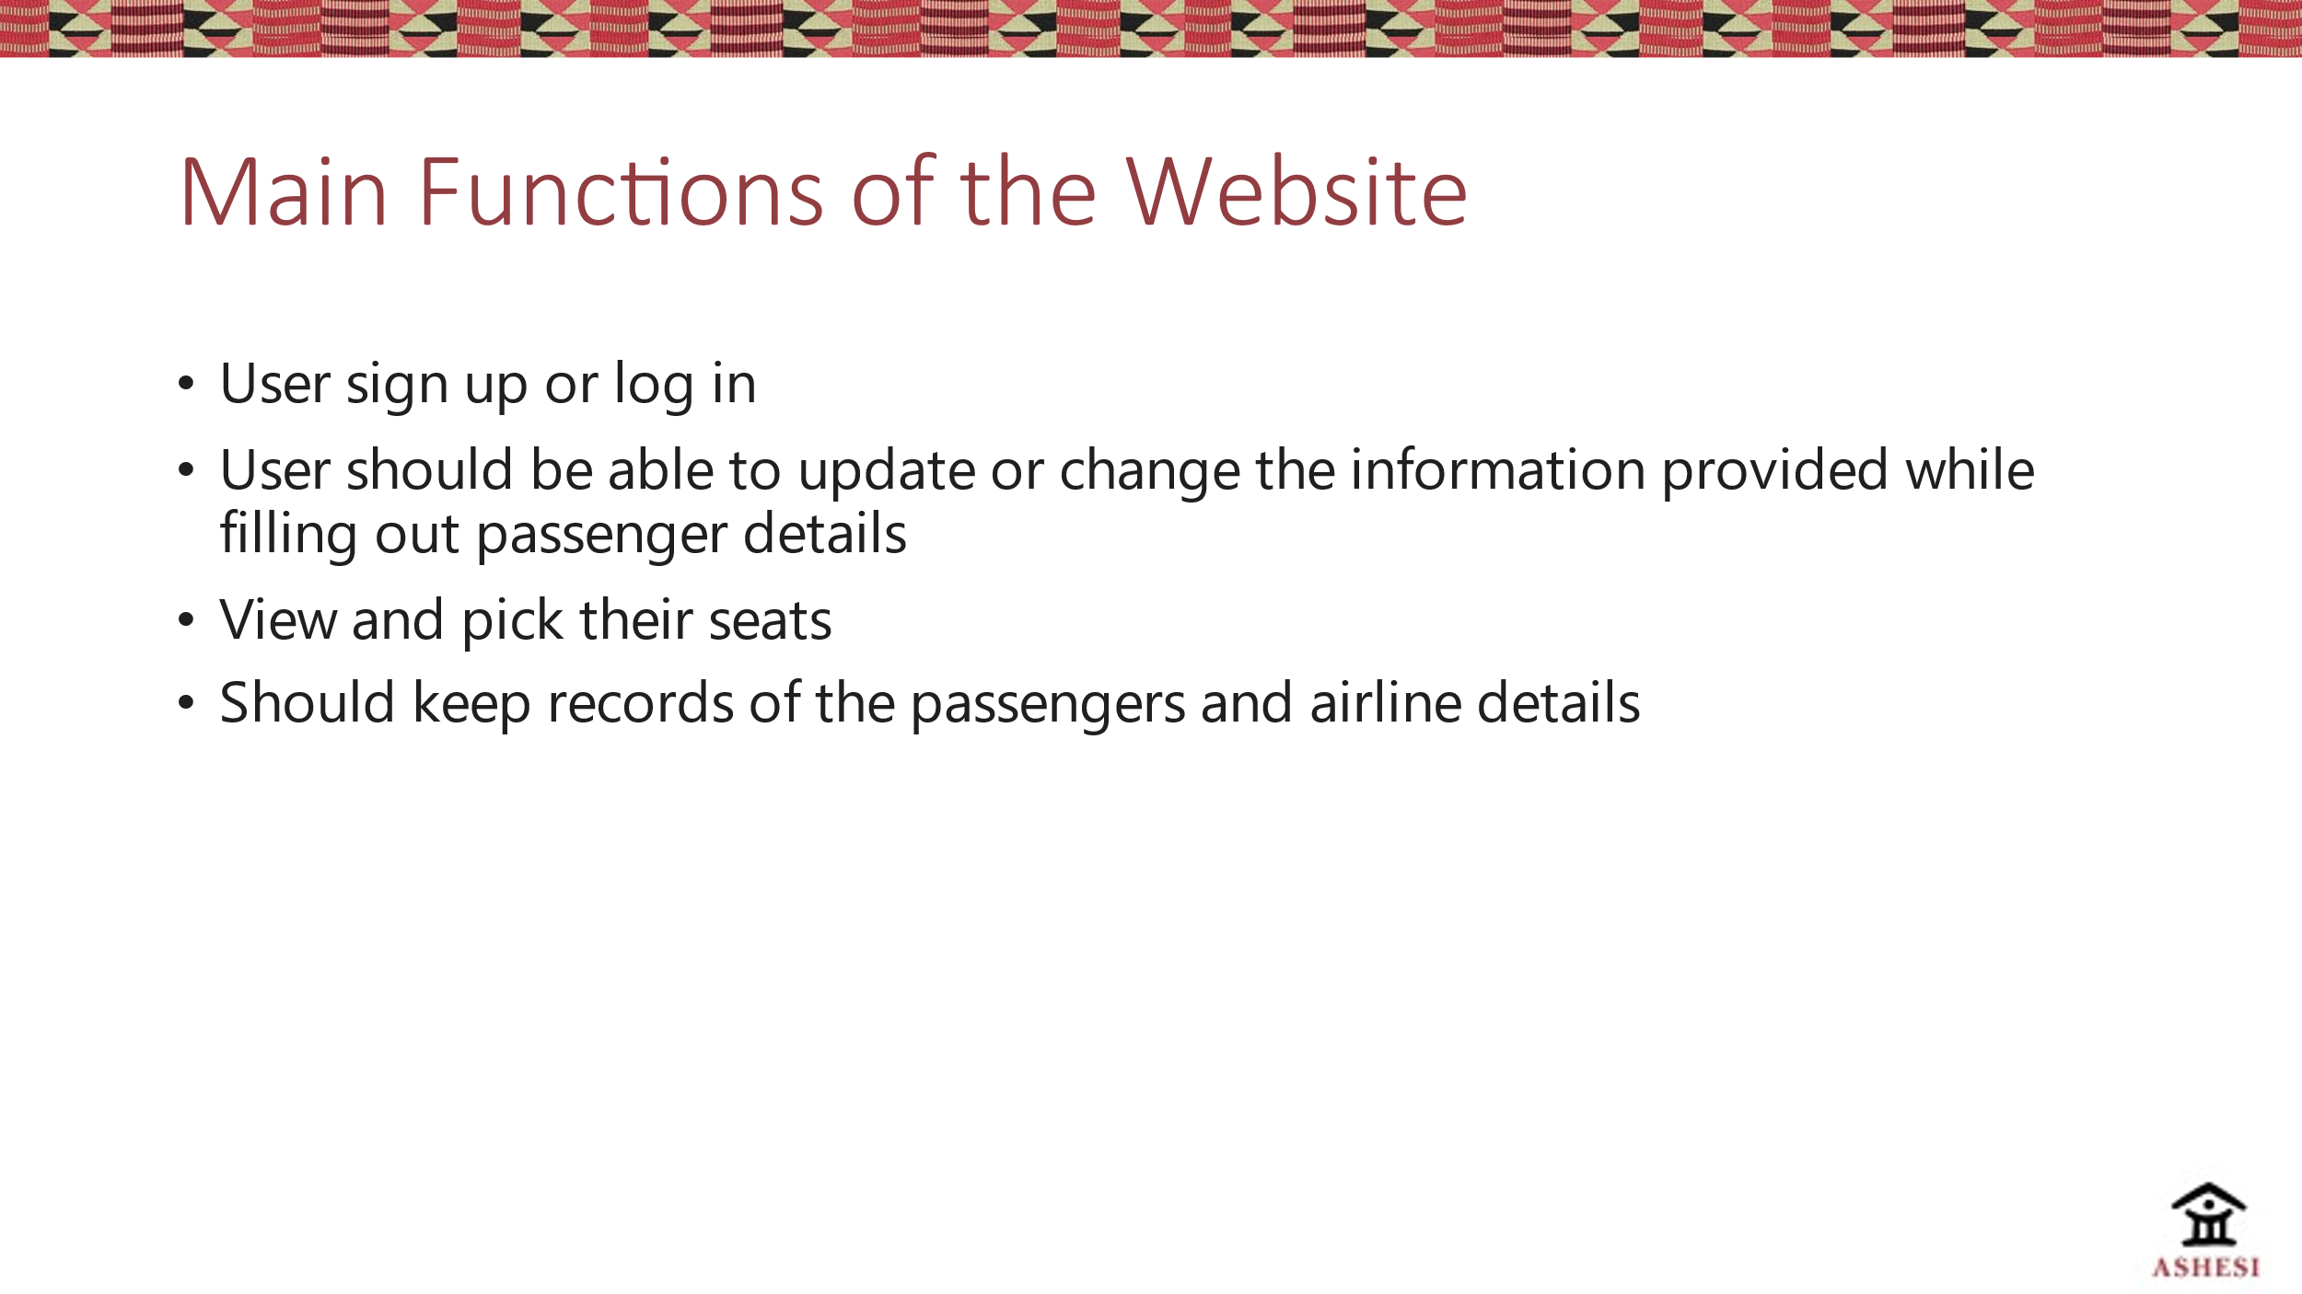

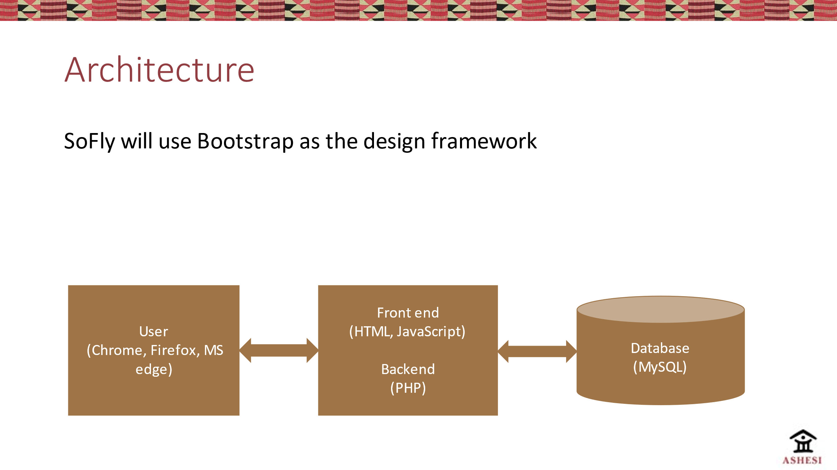

**LINK TO GITHUB REPOSITORY:**

<https://github.com/carole-gasaro/webtechProject.git>

**LINK TO DEMO VIDEO:**

<https://drive.google.com/drive/folders/1USu7sMhHjEvYSW0Hb7P1RgFrB4h1-0Jw?usp=sharing>

**PUBLIC IP TO LIVE WEB SERVER:** 51.145.89.76